VĂN LANG UNIVERSITY
INFORMATION TECHNOLOGY DEPARTMENT

Software Measurement & Analysis

Team: 01
Class: K15T1
Members:
Name | ID
Lê Thị Bích Vân | T09
Đỗ Minh Tâm | T09
Lê Đình Thạch Huyên | T097590
Đặng Huy Sơn | T094967
Nguyễn Trung Tín | T097676

Table of Content

1. Introduction 2
2. The process of team 2
3. Team roles and responsibility 3
4. Meeting Schedule 5

  - Introduction
- The purpose of this document is to provide a brief summary of the regulations of the cooperation of this team and outlines its basic activities.
- This team has been created to work collectively on Software Measurement and Analysis course.
- The process of team.
- Team roles and responsibilities.
- Schedule.
  - The process of team
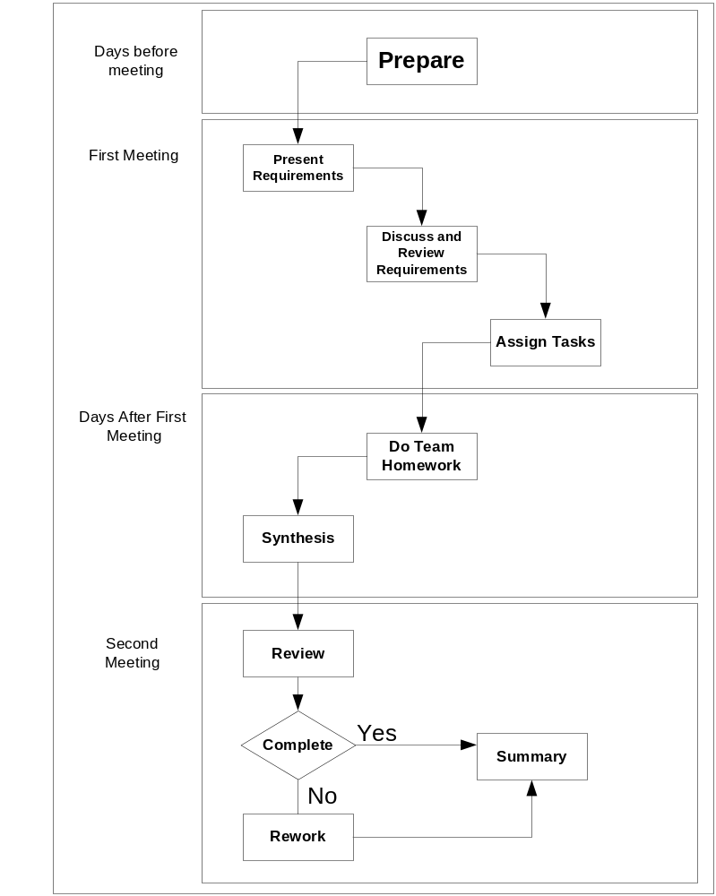

Steps | Description
Prepare | In first step, team member whom is assigned task to analysis team assignment title will preview problems in assignment.  Have to compose and delivery objects of meeting, problems need to discuss and tasks will give to each member in assignment.
Present requirement | Team member whom is assigned task to analysis team assignment title have to present the objects of meeting, problems and tasks to do for his/her team.
Discuss and review | Everybody in team will discuss the giving problems in previous step. Review objects of team assignment and tasks to do.  Everybody will modify objects and tasks to do together in this meeting after discussion.
Assisgn tasks | Team leader will assign works for each people.
Do Team homework | Team members will complete their works at home and send them to sub-leader.
Synthesis | Sub-leader will collect and integrated, preview final document and prepare to present.  Sub-leader sent final version to leader to pre-review.
Review | In this meeting, everybody will review and ensure assignment was finished. Documents were completed and check spelling errors.
Rework | If detect problems in documents, everybody will discuss and solve it in this meeting.
Summary | Team leader collect effort logs of people, get lessons learned together and improve process for next assignment.  After meeting, leader evaluate team members effort and submit.
  - Team roles and responsibility
- President (sponsor): Tô Đình Hiếu
- Budget approval.
- Owner of the overall business change that is being supported by the project.
- Team leader: Lê Thị Bích Vân
  - Team Leader: is a member of the project team, who is responsible for the coordination of the teamwork. During the semester, sponsor may communicate with the Team Leader to check project activities and status.
- Planing and scheduling then assigns the activities for each team members. In the meeting, all of the members should been assigned their works.
- Prepare project plans. Ensure tools and methodologies are being adhered to Reports status.
- Preparing for two meetings. If necessary, Team Leader can conduct the meeting on Saturday at 1.00 pm for updating final of team assignment.
- Monitor: Prepare and monitor meeting. Oversees day-to-day operations.
- Review effort log of each member. Evaluate the work of members.
- Team Leader will also prepare Power Point themeplates slides for presentation or the others themeplate documents.
- Sub-leader:
- Support Leader analysis of the main requirements and prepare an agenda for the meeting and post it on the team website. After the meeting has been conducted, the results of the meeting must be store in repository.
- Support Leader will have received completed parts of the assignment from other members. Will combine the whole Assignment and release (send it by email to all members and put it on the Team’s repository) the draft of assignment on Tuesday. Team will comment on the whole assignment. It is a responsibility of the Team Leader to submit the Assignment on the due date of the assignment using the submission server.
- Recorder: Đỗ Minh Tâm
- Internal documentation and system documentation.
- Provide resources.
- Collect effort logs.
- Team members:
- Write effort log and send to recorder or submit in repository. Team members must complete their assigned works on time.
- Observe internal rules of team.
- Design and develop.
  - Meeting Schedule
- The following dates represent the meeting schedule for team per week:
- Monday – at 10:30 am
- Wednesday – at 10:30 am to
- May be Saturday – at 10:30 am to 1.00 pm. See the section 3 to understand content in each meeting.
- Schedule content is described in attached excel:
- Schedule_Viking_Project_K15T1_Team1

